

**CYS LTD.**



CYS-Fest!

**At Parham Airfield on Saturday 25th June 11am-7pm**

**STALLS!**



**BRING A PICNIC!**

**WORKSHOPS!**

**ARTS & CRAFTS!**

**LIVE MUSIC!**



**£3 ADVANCE TICKETS**

**£5 ON THE DOOR**

**Under 5’s go free**

**See reverse**

**www.wiredcys.co.uk**

**WORKSHOPS!**

**Supporting people with additional needs**

**How to find us…**

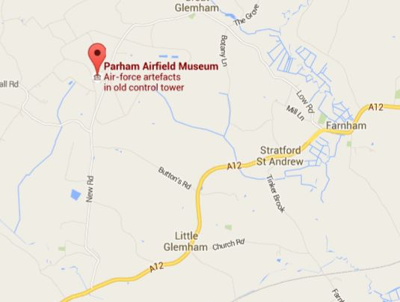

Parham Airfield – IP13 9AF

Situated on open fields, the airfield museum is sign posted from the A12 to the north of Woodbridge after passing through Little Glemham

**Buying your tickets…**

You can order your tickets through our website – Just follow the links

Cheques made payable to: Wired CYS LTD. and sent to 1, Middleton Moor, Saxmundham, Suffolk, IP17 3LN

Cash accepted

Bring your own chair!! Car park on site

For queries contact: [wiredconnectyoursenses@outlook.com](mailto:wiredconnectyoursenses@outlook.com)

07872904877 ~ 07534852162

Wired CYS LTD. Company no:

Parham Airfield Museum - Registered Charity No 284146  
Member of MLA & BAPC